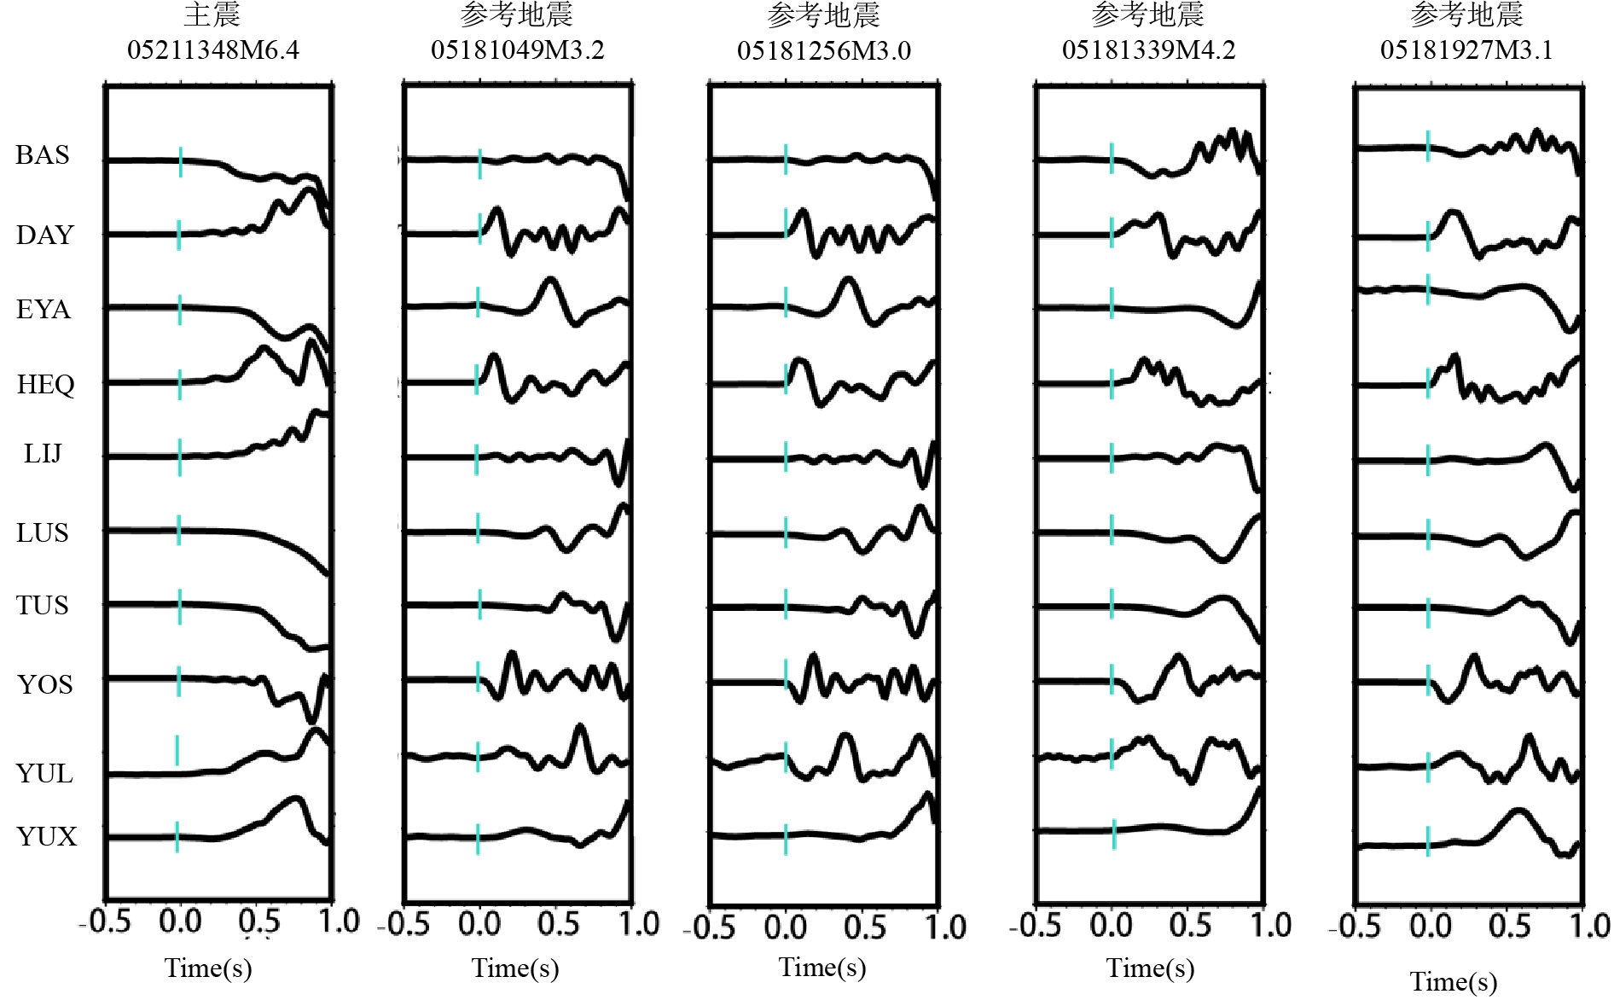
蓝线为P波拾取标记，波形左侧字母为台站名
附图 1主震与部分参考地震的P波波形拾取图
Appx. Fig. 1. P-wave waveform picks for the mainshock and selected reference earthquakes
The blue lines are P-wave picking markers, and the letters on the left side of the waveforms are station names.
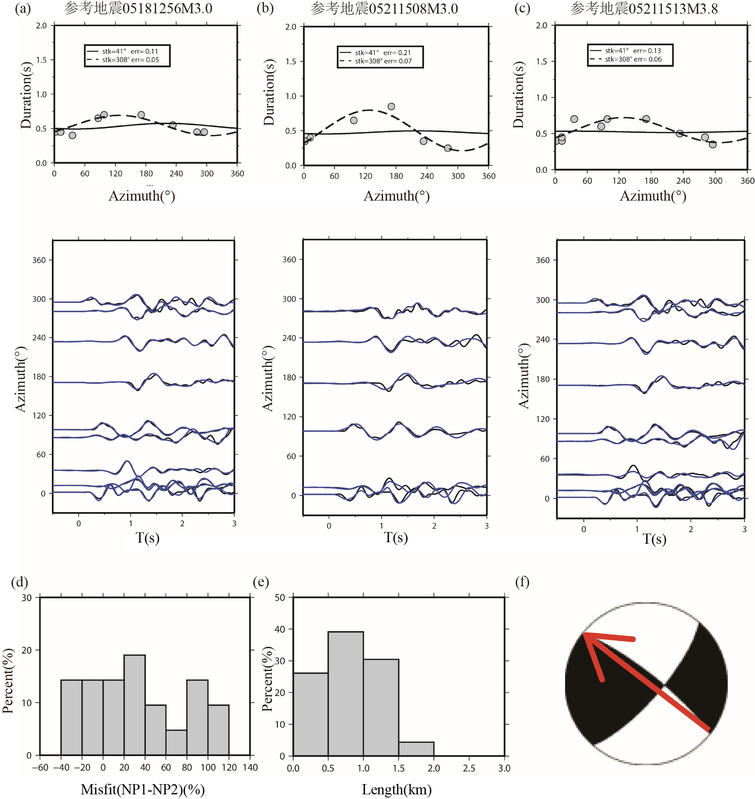
附图 2 震源时频特征法测定0518 M_{S} 4.2前震破裂方向性
Appx. Fig. 2. Rupture directivity of the 0518 M_{S} 4.2 foreshock determined by the source time–frequency characteristic method

